

The Islamia University of Bahawalpur

Department of Information Technology
Faculty of Computing

Software Design Document

Student Grade Prediction System

Submitted by

Aiza Tanveer

Roll no

S23BINFT1M01048

Submitted to

Dr. Rana Nazir Ahmad

Summary

This Software Design Description (SDD) presents the internal architecture and detailed design of the Student Grade Prediction System, a machine learning-powered web application developed as a Final Year Project for the Department of Information Technology, Islamia University of Bahawalpur. The system helps teachers and students predict final academic grades based on three key input features: class attendance percentage, weekly study hours, and previous exam marks, using Linear Regression and Decision Tree classifiers.
This document covers: (1) Application Architecture describing the Flask-based MVC structure, ML prediction module, role-based authentication, and all major components; (2) Data Model Schema defining all three database tables with full field specifications and ER relationships; and (3) User Interface design covering all eight role-specific pages. All seven required UML diagrams are embedded in their relevant sections. Screen images for all five application pages are included in Section 3.4.

Table of Contents

Summary

Table of Contents

- Application Architecture

  - Architecture Pattern
........................
........................
.......................
........................
........................
............
........................
........................
...
.........................
.........................
....

II

III

1

1

  - Components and Their Roles ......................... 1
.......................
  - Key Functions in predict.py ......................... 2
......................
  - External Libraries and APIs ......................... 3
......................
.........................

  - Coding Conventions
  - UML Diagrams
......................... 3
......
.........................
......................... 4
............

    - Figure 1 — System Context Diagram ........................... 4
............
    - Figure 2 — Data Flow Diagram (Level 0 and Level 1) ...................... 5
    - Figure 3 — Sequence Diagram ........................... 6
..................
    - Figure 4 — Activity Diagram ........................... 7
..................
    - Figure 5 — Component Diagram ........................... 8
.................
    - Figure 6 — Class Diagram ...........................
9
.....................
    - Figure 7 — Use Case Diagram ...........................
10
.................
........................

Data Model Schema

  - Table 1 — Users
........................ 11
.........
.........................
......................... 11
........

  - Table 2 — Predictions

  - Table 3 — Models
.........................
......................... 12
..
.........................
......................... 12
.......

  - Entity-Relationship Summary ......................... 13
.....................
  - In-Memory Flask Session Variables ......................... 13
...............
........................

- User Interface
........................ 14
............

  - Design and Interface Specifications ......................... 14
.............
  - List of Pages and Screen Descriptions ......................... 14
...........
  - Controls, Input Constraints, and Feedback ......................... 15
.......
.........................

  - Screen Images
    - Home Screen
......................... 16
..........
...........................
........................... 16
......

    - Upload and Detect Screen ...........................
17
....................
...........................

    - Results Screen

    - History Screen

    - About Screen

Appendix A: Glossary
........................... 18
...
...........................
........................... 19
...
...........................
........................... 20
.....
........................
........................ 21
..........

Appendix B: Design Models Summary ........................ 22
.....................
........................

References
........................ 22
....................

1. Application Architecture

The Student Grade Prediction System follows a three-layer MVC-inspired architecture. The Presentation Layer uses Flask-rendered Jinja2 HTML/CSS templates. The Application Logic Layer contains all Python route handlers and the ML prediction pipeline. The Data Layer uses a relational SQLite database. All layers communicate through well-defined function calls with no direct client-to-database access.

Architecture Pattern
The system follows the Model-View-Controller (MVC) pattern adapted for Flask. Flask route handlers act as Controllers, Jinja2 HTML templates are the View, and Python modules (predict.py, auth.py, db.py) are the Model. This separation ensures the ML algorithm can be retrained without changing the interface, and the interface can be redesigned without touching ML or database logic.

Components and Their Roles

Component | Role
app.py | Main Flask entry point. Registers all route blueprints, initialises DB, configures session secret key.
auth.py | Authentication logic: registration (bcrypt hashing), login validation, session creation, 30-min expiry.
predict.py | Core ML module. load_model(), predict_grade(), get_feature_importance(). Loads Scikit-learn .pkl model.
db.py | Data access module. All CRUD functions for users, predictions, model metadata. Parameterised SQL.
train.py | Offline training script. Loads CSV, splits data, trains both models, evaluates accuracy, saves model.pkl.
templates/ | Jinja2 HTML pages: login, register, student_dashboard, predict, results, teacher_dashboard, analytics, admin.
static/ | CSS, Chart.js, and client-side validation scripts.

Key Functions in predict.py

load_model(model_path)
Deserialises the trained Scikit-learn model from the .pkl file. Called once at startup. Raises FileNotFoundError if model.pkl is absent.

predict_grade(attendance, study_hours, previous_marks, model)
Accepts three validated floats. Scales inputs via StandardScaler, passes vector to Decision Tree for grade label (A-F) and to Linear Regression for numeric score. Returns a PredictionResult dictionary with predicted_grade, numeric_score, and confidence.

get_feature_importance(model)
Extracts feature importance scores from the Decision Tree for the three inputs. Returns a list of (feature_name, score) tuples sorted descending, used on the results page.

External Libraries and APIs

Library / Tool | Purpose
Flask | Web framework - HTTP routing, session management, Jinja2 rendering
Scikit-learn | Linear Regression and Decision Tree training and inference; StandardScaler
Pandas | CSV dataset loading, manipulation, train/test splitting
NumPy | Numerical array operations for feature vectors
bcrypt | Secure password hashing and verification
SQLite3 | Lightweight relational database for users, predictions, and model records
Joblib | Serialisation/deserialisation of trained Scikit-learn models to .pkl
Jinja2 | HTML templating engine integrated with Flask
Chart.js | Client-side analytics charts (grade distribution, correlation scatter plots)

Coding Conventions
- All Python files follow PEP 8 naming conventions throughout.
- Functions use lowercase_with_underscores naming style.
- Constants (MODEL_PATH, SECRET_KEY, DB_PATH) defined in config.py at project root.
- All route functions documented with docstrings describing route, method, and return value.
- Type hints used for all function parameters and return values in ML and DB modules.
- All SQL queries use parameterised statements (?, ?) to prevent SQL injection.
- Comments written in plain English to explain non-obvious logic.

UML Diagrams

Figure 1 - System Context Diagram
The System Context Diagram shows the Student Grade Prediction System as the central bounded system. External entities: (1) Student - submits data, views predicted grade; (2) Teacher - views class results and analytics; (3) Administrator - manages users and retrains the ML model; (4) Kaggle Dataset - used offline for training only; (5) Python/Flask Runtime - hosts the entire application.

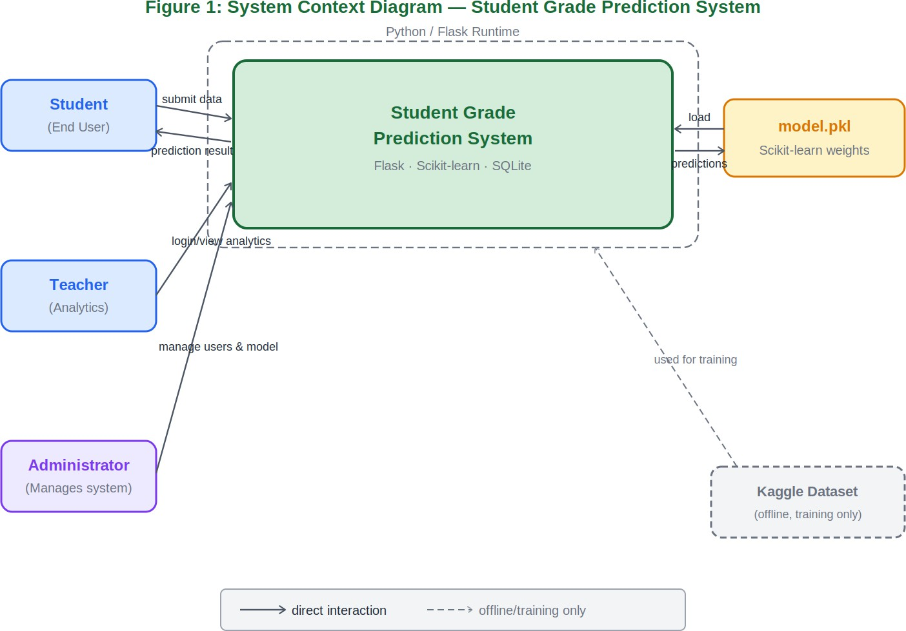
Figure 1: System Context Diagram - Student Grade Prediction System

Figure 2 - Data Flow Diagram (Level 0 and Level 1)
Level 0 shows the entire system as a single process. Level 1 decomposes it into five sub-processes: 1.1 Authenticate User; 1.2 Validate Input; 1.3 Run Prediction (using D3 model.pkl); 1.4 Store Results (into D2 Predictions); 1.5 Display Results. Data stores: D1 Users, D2 Predictions, D3 model.pkl.
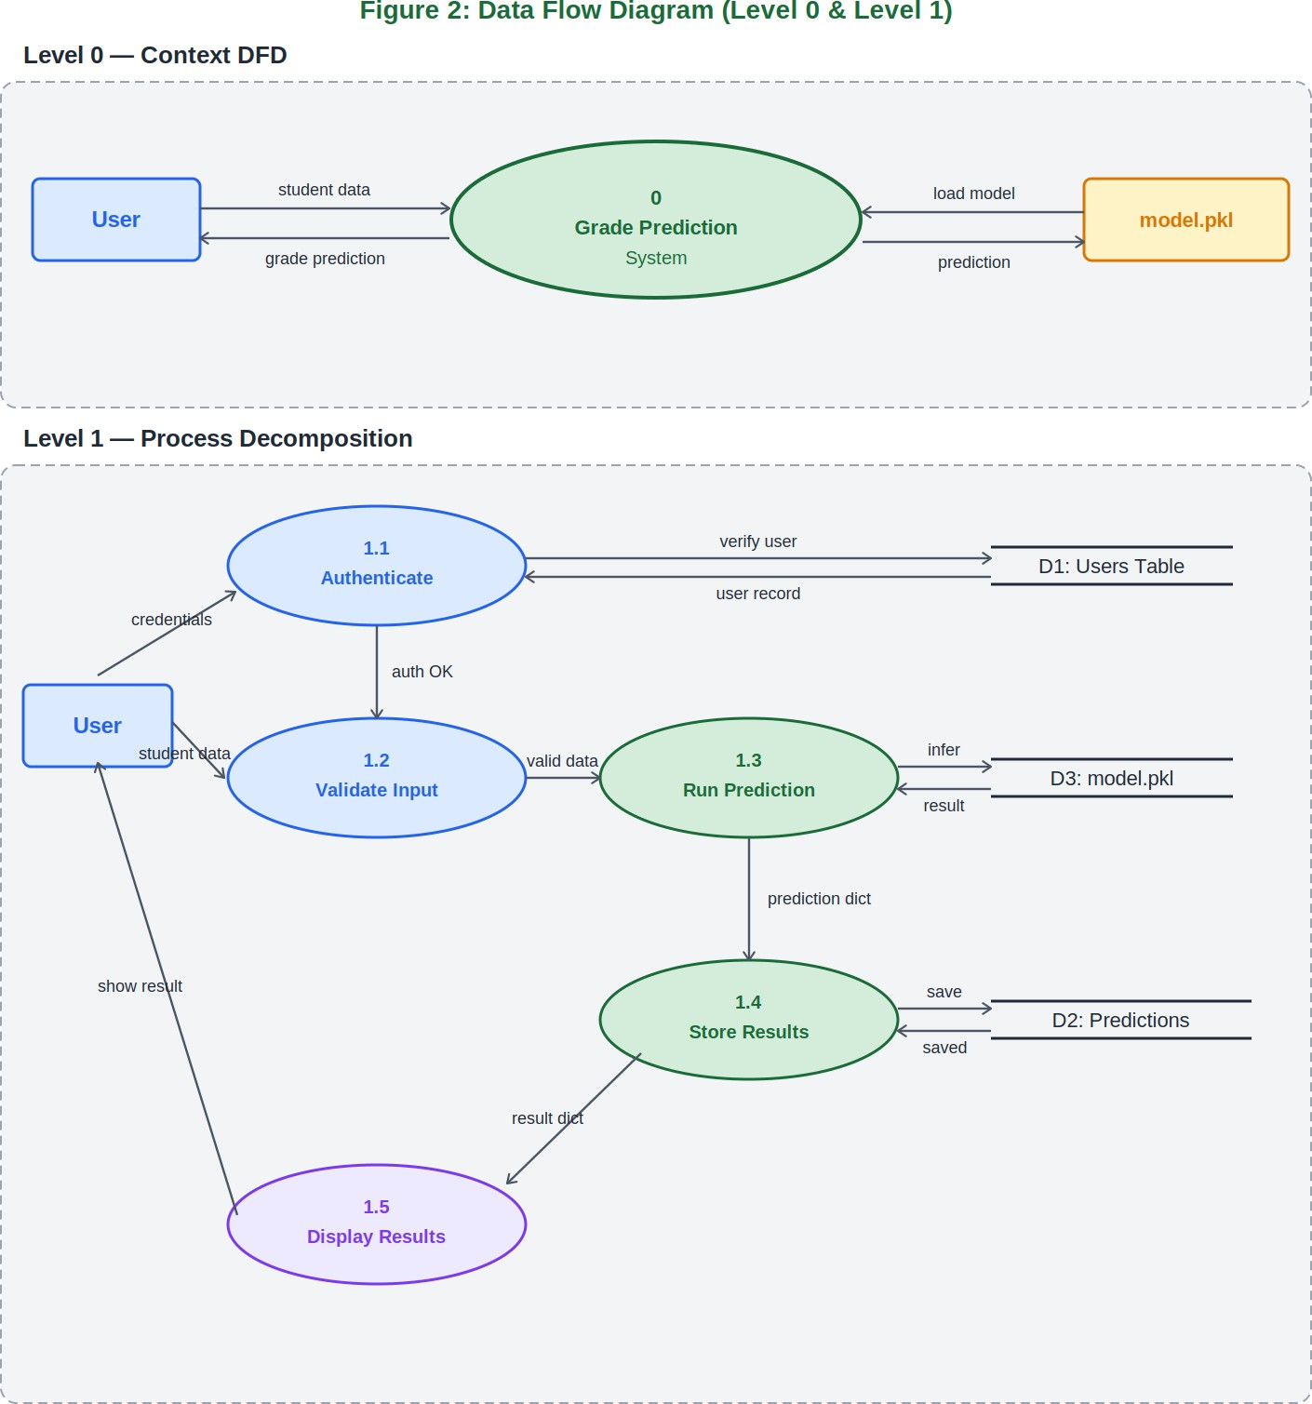
Figure 2: Data Flow Diagram (Level 0 and Level 1)

Figure 3 - Sequence Diagram
Shows message flow between: User, Flask Web UI, predict.py, Scikit-learn Model, and SQLite DB. Solid arrows are synchronous calls; dashed arrows are return messages. An alt block covers the model-missing error case.
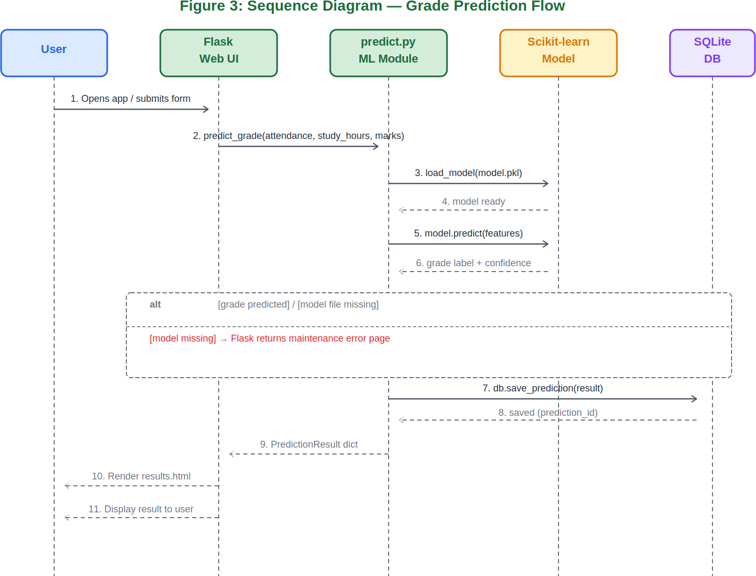

Figure 3: Sequence Diagram - Grade Prediction Flow

Figure 4 - Activity Diagram
Shows complete control flow from app startup through login, role routing, data entry, validation, ML inference, result display, and session end. Decision nodes: Has Account?, Valid Credentials?, Valid Input?, Model Ready?, Predict Another?
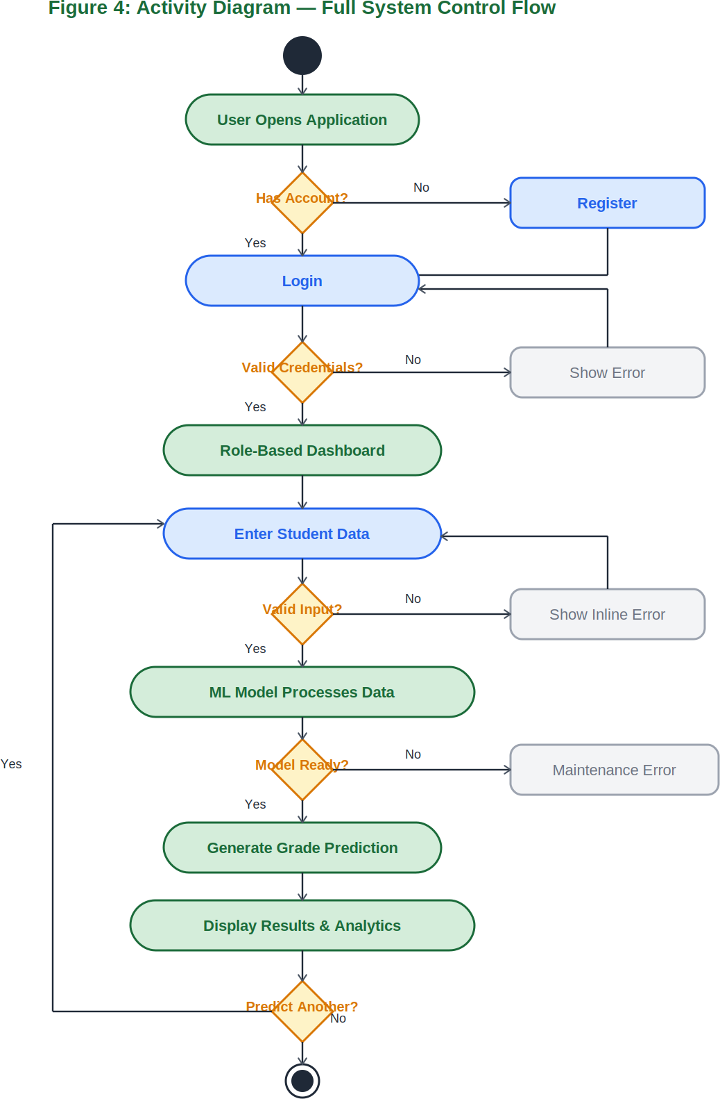

Figure 4: Activity Diagram - Full System Control Flow

Figure 5 - Component Diagram
Three subsystems: (1) Presentation Layer - app.py, auth.py, Jinja2 templates, static, Flask Session; (2) Application Layer - predict.py, db.py, train.py; (3) Storage/External Layer - model.pkl, SQLite DB, Kaggle dataset (offline), Scikit-learn library.
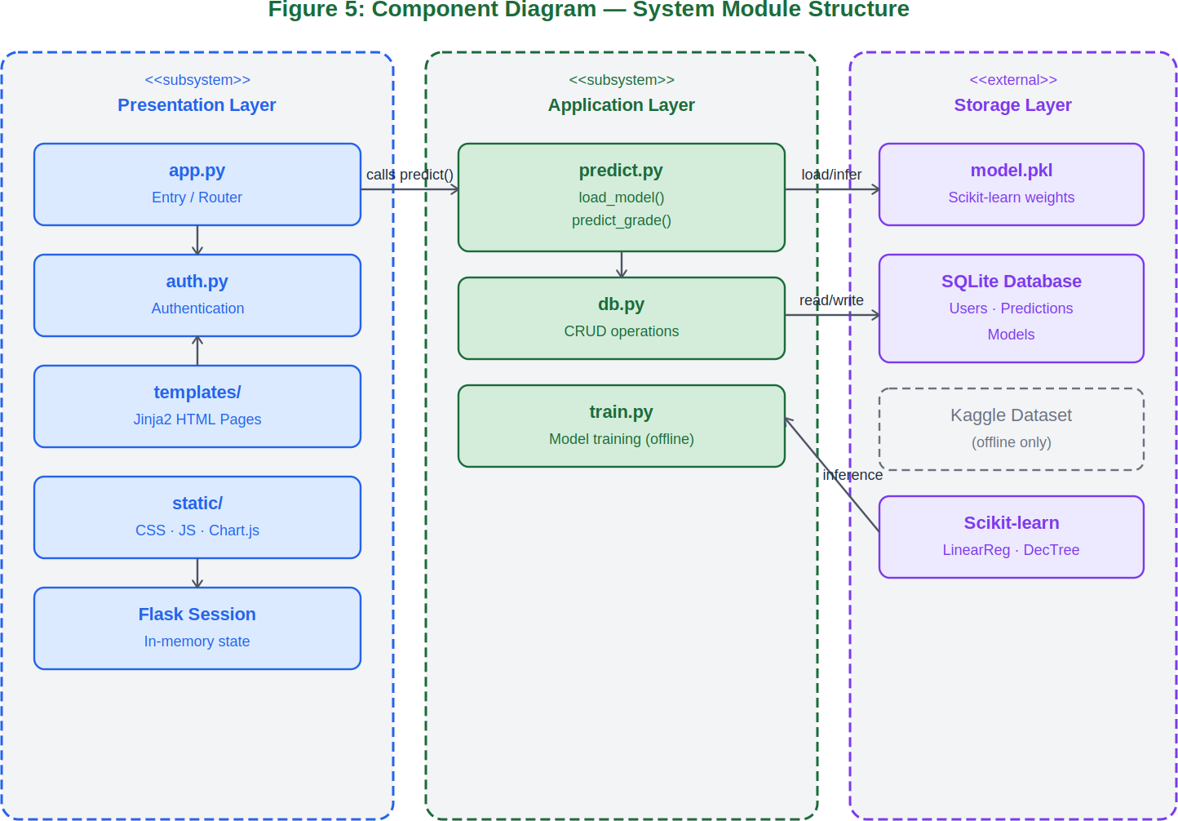

Figure 5: Component Diagram - System Module Structure

Figure 6 - Class Diagram
Six main classes: GradePredictionApp, PredictionEngine, PredictionResult, AuthManager, UserRecord, AnalyticsDashboard. Relationships: GradePredictionApp uses PredictionEngine and AuthManager; PredictionEngine creates PredictionResult; AuthManager manages UserRecord; AnalyticsDashboard reads PredictionResult records.
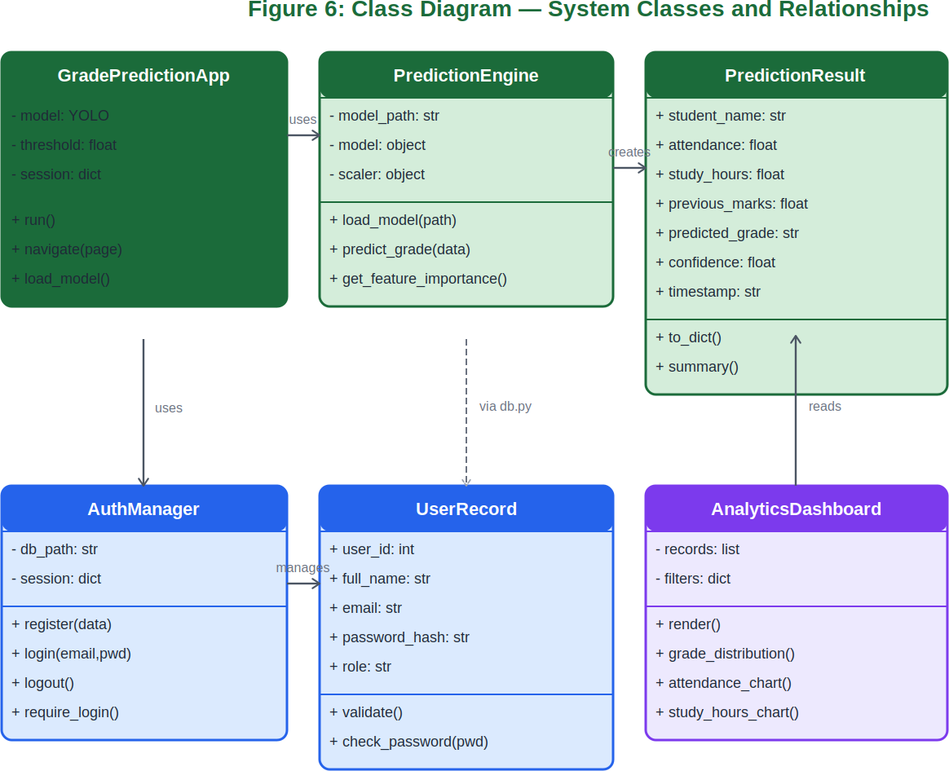

Figure 6: Class Diagram - System Classes and Relationships

Figure 7 - System Use Case Diagram
Three actors: Student, Teacher, Administrator. Seven use cases: UC001 Login/Register (all actors), UC002 Enter Student Data, UC003 Predict Grade (include), UC004 View Results (include), UC005 View Analytics (Teacher+Admin), UC006 Manage Model (Admin), UC007 Manage Users (Admin).
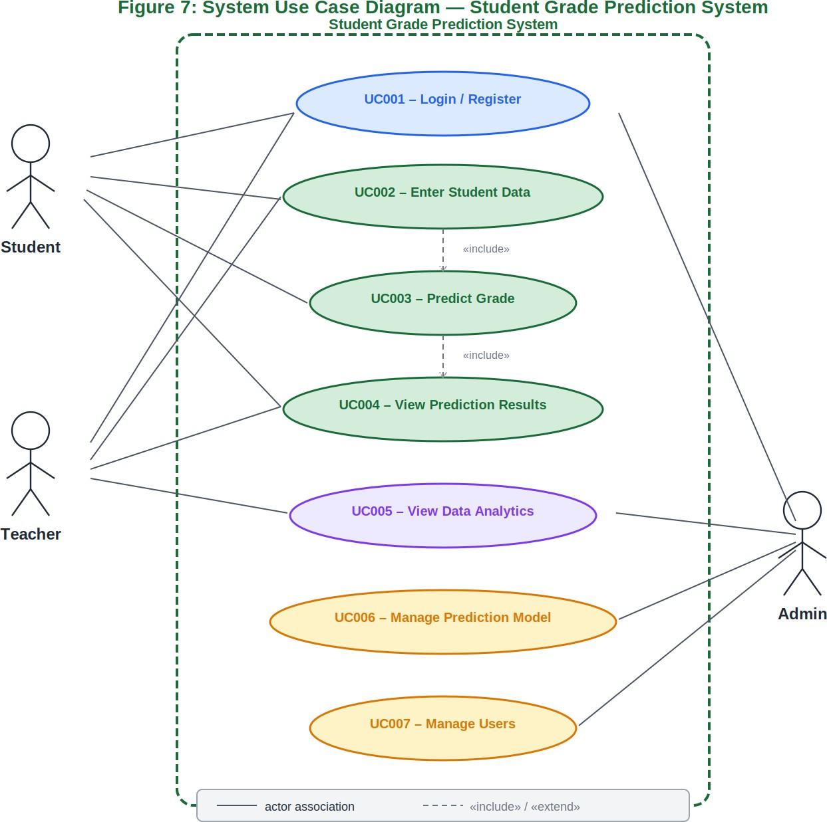
Figure 7: System Use Case Diagram - Student Grade Prediction System

2. Data Model Schema

The system uses a relational SQLite database with three tables initialised by db.py on first run. Passwords are hashed with bcrypt. All SQL uses parameterised queries.

Table 1 - Users
Stores all registered user accounts for the three roles: Student, Teacher, Administrator.

Field | Type | Constraint | Description
user_id | INTEGER | PK, AUTO | Unique user identifier
full_name | TEXT | NOT NULL | Full name of the user
email | TEXT | UNIQUE, NOT NULL | Login identifier - must be valid and unique
password_hash | TEXT | NOT NULL | bcrypt-hashed password (never stored plain)
role | TEXT | CHECK IN | One of: student, teacher, administrator
phone_number | TEXT | NULLABLE | Optional contact number
created_at | DATETIME | DEFAULT NOW | Timestamp of account creation

Table 2 - Predictions
Each row is one grade prediction run, linked to Users by student_id.

Field | Type | Constraint | Description
prediction_id | INTEGER | PK, AUTO | Unique prediction record identifier
student_id | INTEGER | FK to Users | References user_id of the student
student_name | TEXT | NOT NULL | Name of student for display purposes
attendance_pct | REAL | 0 to 100 | Attendance percentage input
study_hours | REAL | > 0 | Weekly study hours input
previous_marks | REAL | 0 to 100 | Previous exam marks/GPA input
predicted_grade | TEXT | NOT NULL | Output: A, B, C, D, or F
numeric_score | REAL | NULLABLE | Numeric score from Linear Regression
confidence | REAL | 0 to 1 | Model confidence score for the prediction
model_id | INTEGER | FK to Models | References the model version used
predicted_at | DATETIME | DEFAULT NOW | Timestamp when prediction was made

Table 3 - Models
Tracks all trained model versions. Only one record has is_active = 1 at a time.

Field | Type | Constraint | Description
model_id | INTEGER | PK, AUTO | Unique model version identifier

Field | Type | Constraint | Description
algorithm | TEXT | NOT NULL | linear_regression or decision_tree
accuracy | REAL | NOT NULL | Accuracy on hold-out test set (e.g. 0.87)
dataset_rows | INTEGER | NULLABLE | Number of training rows used
is_active | INTEGER | 0 or 1 | 1 = this model is currently in use
model_path | TEXT | NOT NULL | Filesystem path to the .pkl file
trained_at | DATETIME | DEFAULT NOW | Timestamp of model training completion

Entity-Relationship Summary
Users (1) to Predictions (many) - one student can have many prediction records. Models (1) to Predictions (many)
- one model version is linked to many predictions. The is_active flag ensures a single active model at any time. Historical records are preserved even if a user is deactivated.

In-Memory Flask Session Variables
    - session['user_id']: Integer. The authenticated user's primary key.
    - session['role']: String. One of: student, teacher, administrator. Used by all role-gating decorators.
    - session['last_activity']: Datetime. Updated on every request; enforces the 30-minute session timeout.
    - session['last_prediction']: Dictionary. Holds the most recent PredictionResult for the results page.

3. User Interface

The system provides a clean, role-aware web interface built with Flask, Jinja2, HTML5, and CSS3. Designed to be usable by a non-technical student within two minutes without instructions. A persistent top navigation bar provides role-specific links.

Design and Interface Specifications

Color Palette and Visual Hierarchy

Element | Color | Purpose
Navigation Bar | #1A1A1A (Dark) | Consistent anchor across all pages
Page Background | #F5F5F5 (Light Grey) | Readability against white card panels
Primary Buttons | #000000 (Black) | Submit Prediction, Login, Register
Grade A/B Indicator | Black fill | High-performing prediction badge
Grade F Indicator | Light Grey + border | At-risk prediction requiring attention
Secondary Actions | White + border | View Details, Download, Back
Warning / Grade C | Light Grey | Medium-grade predictions

    - Typography
System-native sans-serif (Arial, Helvetica). Page titles: 24pt bold. Section headings: 18pt bold. Body text and labels: 14pt regular. Metric values (grade, confidence): 32pt bold. No external fonts imported.

Layout
Desktop-first at 1280px minimum. Fixed top navigation bar. Centered container, max-width 1100px. CSS Flexbox for multi-column layouts. Forms: single-column, max-width 480px.

List of Pages and Screen Descriptions

Page 1 - Login / Register
Entry page with Login and Register tabs. Login: email and password. Register: full name, email, password, role selector (Student/Teacher), phone number. On success: redirected to role-specific dashboard.

Page 2 - Student Dashboard
Welcome card with student name. Three summary cards: Total Predictions, Latest Grade, Latest Confidence. Prediction history table. Prominent Predict My Grade button.

Page 3 - Enter Student Data (Predict Grade Form)
Centered form: Student Name, Attendance (0-100), Weekly Study Hours (>0), Previous Marks (0-100). Inline validation on all fields. Loading spinner during ML inference.

Page 4 - Prediction Results
Large grade label (A-F); confidence score; input summary table; feature importance bar chart; model accuracy indicator; Predict Another and Back to Dashboard buttons.

Page 5 - Teacher Dashboard
Three metric cards: Total Predictions, Avg Confidence, Class Average Grade. Filterable predictions table.

Page 6 - Analytics Dashboard
Grade Distribution Bar Chart; Attendance vs Grade Scatter Plot; Study Hours vs Grade Scatter Plot. Optional date-range filter. Export CSV button.

Page 7 - Admin Dashboard
Summary cards: Total Users, Active Model Accuracy, Total Predictions. User Management and Model Management panels.

Page 8 - Model Management
Active model info card. CSV file upload. Algorithm selector. Retrain Model button. Rollback button if accuracy below 75% threshold.

Controls, Input Constraints, and Feedback

Attendance Percentage Field
Type: number. Range 0-100. Step 0.1. Red border on invalid; inline error on blur.

Weekly Study Hours Field
Type: number. Minimum 0.5. Maximum 168. Inline error if zero or negative.

Previous Marks / GPA Field
Type: number. Range 0-100. Accepts decimals. Inline error if out of range.

Predict Grade Button
Disabled until all three fields are valid. On click: loading spinner, POST /predict, stores result in DB and session, redirects to /results.

Login Form
Email: HTML5 type=email. Password: type=password, minimum 8 characters. Failed login: error banner without revealing which field is incorrect.

CSV Upload (Model Management)
Accepts .csv only. Server validates required columns. Minimum 50 rows. Descriptive error on mismatch.

Model Not Found Error
If model.pkl missing at startup: all prediction routes return maintenance error page. Event logged to console.

Screen Images
The following pages show the screen mockups for all five pages of the Student Grade Prediction System interface, designed for desktop browsers at 1280px minimum width.

Home Screen
The landing page. Shows the system title, a Predict Grade Now button, three feature cards, a How It Works strip, and a system information footer bar.
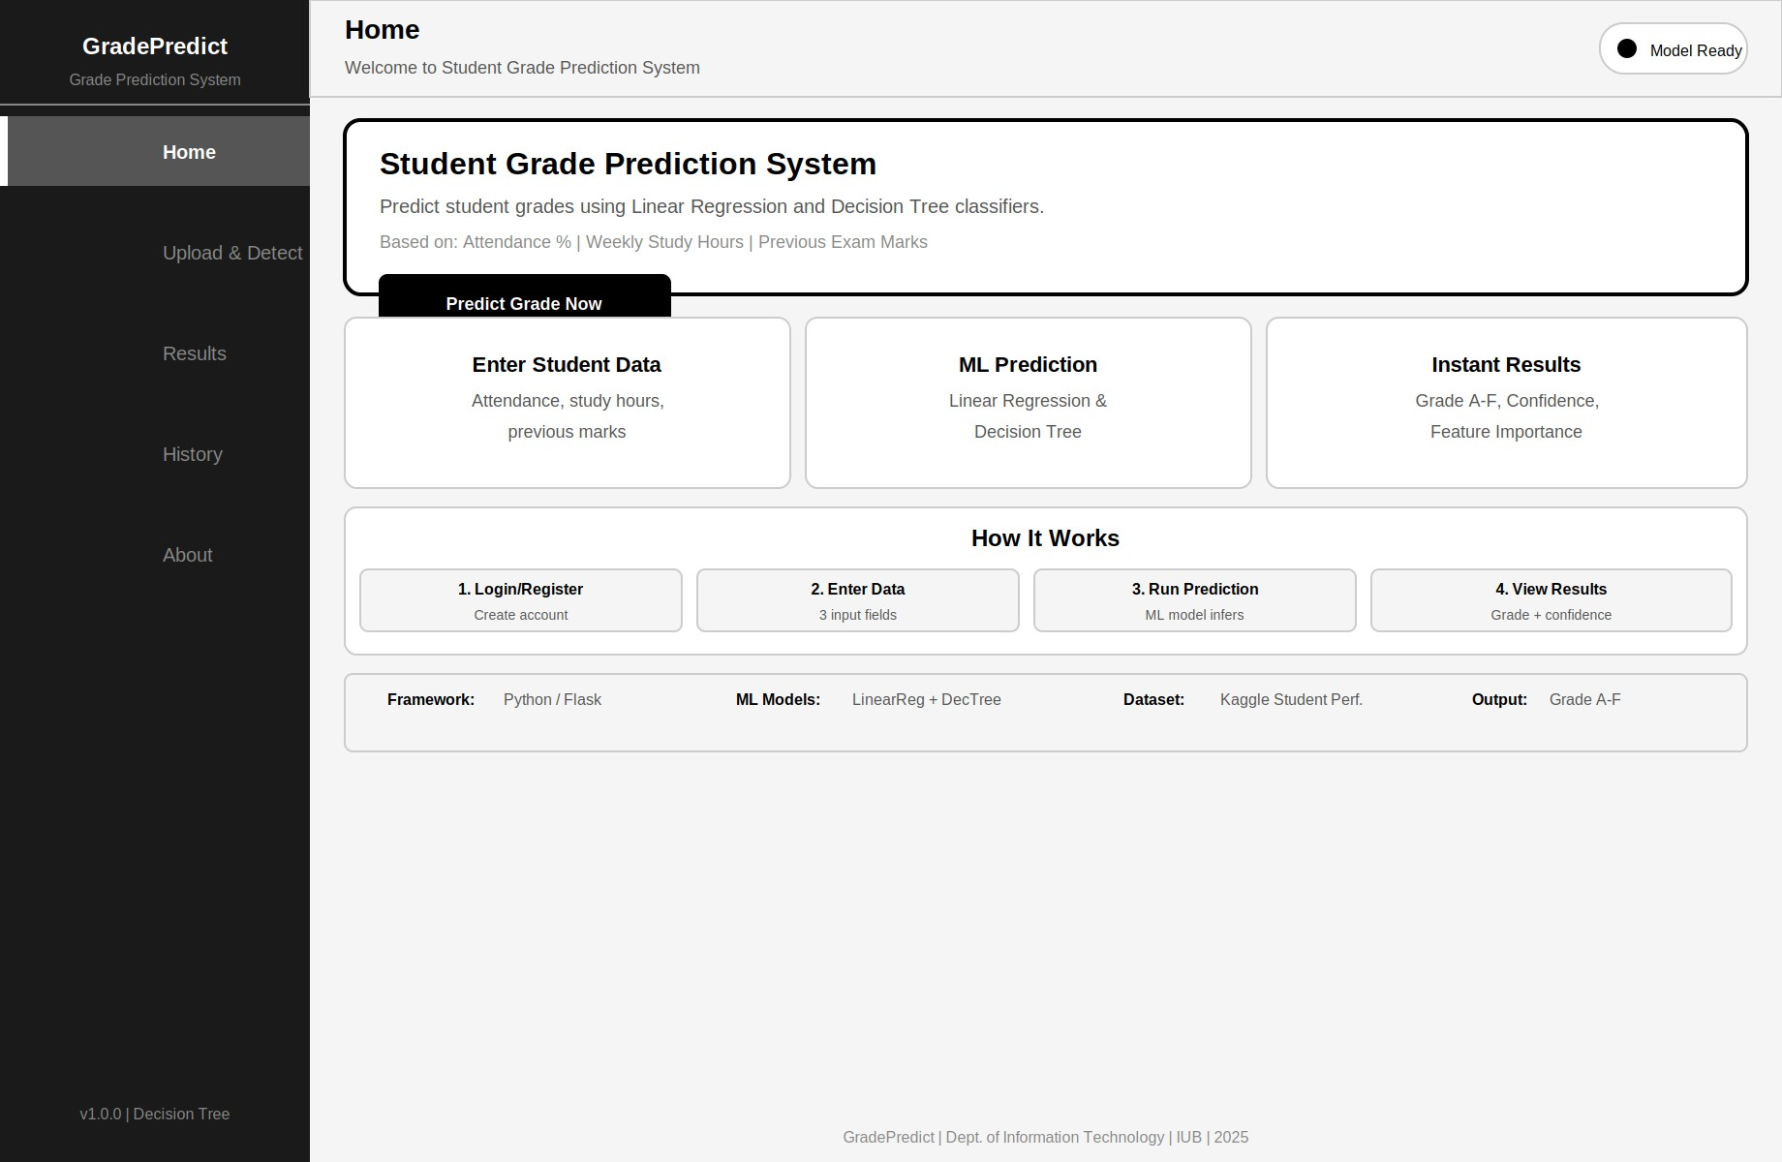
Figure 8: Home Screen - Student Grade Prediction System

Upload and Detect Screen (Enter Student Data)
Primary interactive page. Left panel: student data entry form with three input fields, algorithm selector, and Predict Grade button. Right panel: input guidelines and model info.
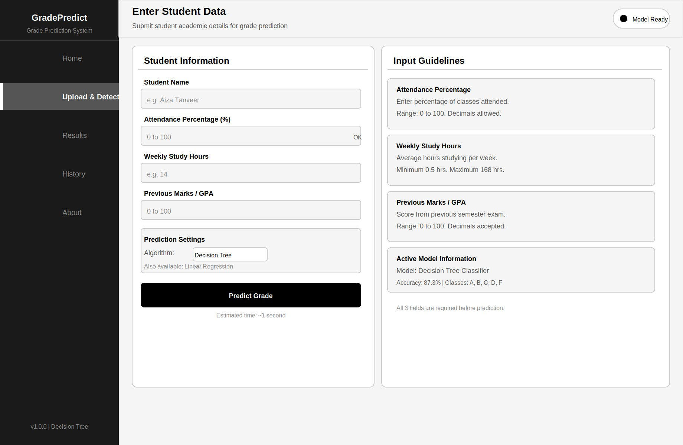
Figure 9: Enter Student Data Screen

Results Screen
Four metric cards (Predicted Grade, Confidence, Numeric Score, Model Accuracy). Input Summary table, Feature Importance bar chart, Grade Probability Breakdown, and action buttons.
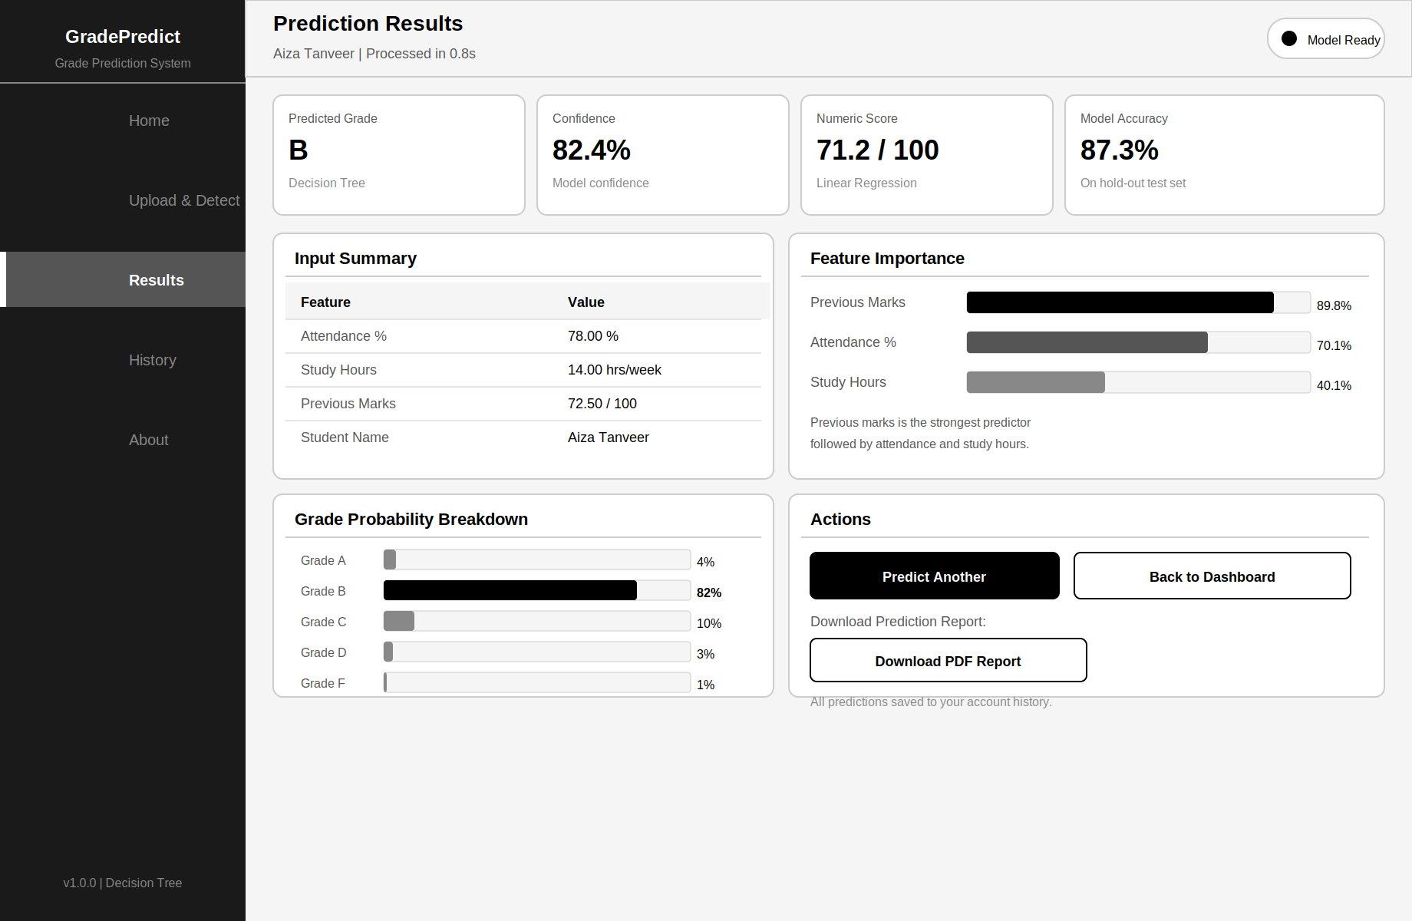
Figure 10: Prediction Results Screen

History Screen
All saved prediction records. Summary cards, filter and search controls, full prediction history table with Grade badges and View buttons.
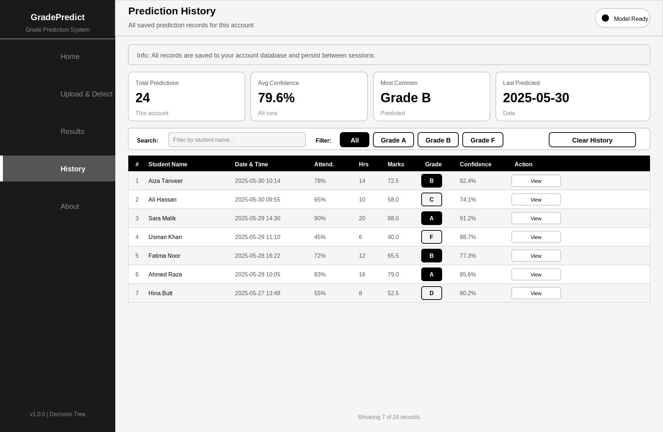
Figure 11: Prediction History Screen

About Screen
Static informational page. Hero card with app name and version badges. Three columns: Project Details, Technology Stack, Model Performance. System flow strip and copyright footer.
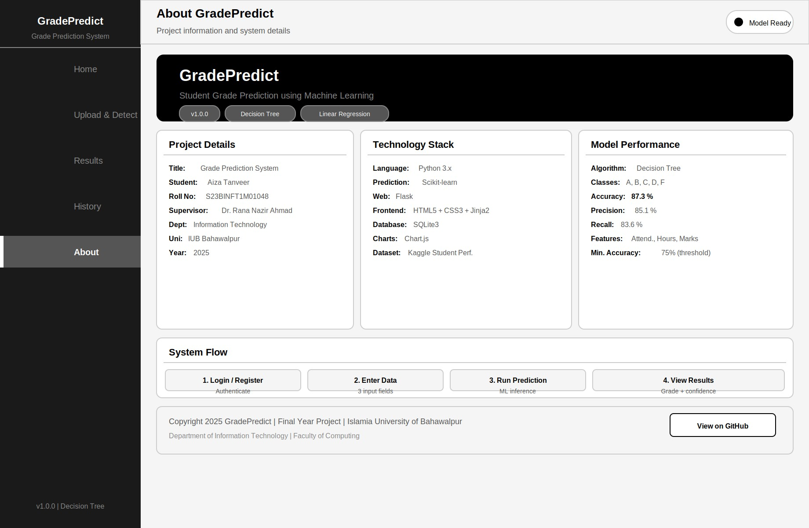
Figure 12: About Screen

Appendix A: Glossary

      - Student Grade Prediction System: The web-based ML application developed as this Final Year Project.
      - Linear Regression: Supervised ML algorithm predicting a continuous numeric score for expected student marks.
      - Decision Tree Classifier: Supervised ML algorithm classifying predicted grade into labels: A, B, C, D, or F.
      - Scikit-learn: Open-source Python ML library used for training and running the prediction models.
      - model.pkl: Serialised trained Scikit-learn model file loaded at application startup for inference.
      - Flask: Lightweight Python web micro-framework for HTTP routing, session management, and Jinja2 templating.
      - Jinja2: Python HTML templating engine integrated with Flask for dynamic page rendering.
      - bcrypt: Cryptographic hashing library used to securely store and verify user passwords.
      - SQLite: Lightweight file-based relational database for users, predictions, and model records.
      - Confidence Score: Float (0-1) representing how certain the Decision Tree model is about the predicted grade.
      - Feature Importance: Ranking of the three inputs by their relative influence on the prediction output.
      - MVC: Model-View-Controller - the pattern separating data, presentation, and control logic.
      - PEP 8: Python community's official style guide for code formatting and documentation.

Appendix B: Design Models Summary
      - Figure 1: System Context Diagram (Section 1.6.1)
      - Figure 2: Data Flow Diagram Level 0 and Level 1 (Section 1.6.2)
      - Figure 3: Sequence Diagram - Grade Prediction Flow (Section 1.6.3)
      - Figure 4: Activity Diagram - Full System Control Flow (Section 1.6.4)
      - Figure 5: Component Diagram - System Module Structure (Section 1.6.5)
      - Figure 6: Class Diagram - System Classes and Relationships (Section 1.6.6)
      - Figure 7: System Use Case Diagram (Section 1.6.7)
      - Figure 8: Home Screen (Section 3.4.1)
      - Figure 9: Enter Student Data Screen (Section 3.4.2)
      - Figure 10: Prediction Results Screen (Section 3.4.3)
      - Figure 11: Prediction History Screen (Section 3.4.4)
      - Figure 12: About Screen (Section 3.4.5)

References
- Cortez, P., & Silva, A. M. G. (2008). Using data mining to predict secondary school student performance. Proceedings of the 5th Annual Future Business Technology Conference, Porto, Portugal.
- Hussain, S., et al. (2018). Educational data mining and analysis of students' academic performance using WEKA. Indonesian Journal of Electrical Engineering and Computer Science, 9(2), 447-459.
- Kaggle. (2023). Students' Performance in Exams Dataset. https://www.kaggle.com/datasets/spscientist/students-performance-in-exams
- Pedregosa, F., et al. (2011). Scikit-learn: Machine learning in Python. Journal of Machine Learning Research, 12, 2825-2830.
- Flask Documentation. (2023). https://flask.palletsprojects.com

- IEEE Std 1016-2009, IEEE Standard for Information Technology Systems Design - Software Design Descriptions.
- IEEE Std 830-1998, IEEE Recommended Practice for Software Requirements Specifications.
- Pressman, R. S., & Maxim, B. R. (2019). Software Engineering: A Practitioner's Approach (9th ed.). McGraw-Hill.

